Russian fighter jet crashes, causing multiple casualties
俄罗斯战机坠毁，造成多人伤亡

A Russian Su-35 fighter jet crashed near an apartment building in the town of Yeysk, killing at least four people and injuring 25.
一架俄罗斯 Su-35 战斗机在叶伊斯克镇的一栋公寓楼附近坠毁，造成至少 4 人死亡，25 人受伤。
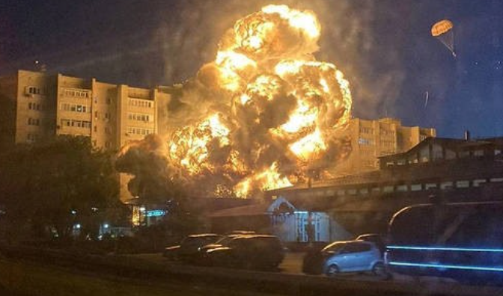

At least four people were killed when a Su-35 multirole fighter jet crashed outside an apartment building in the southern Russian city of Yeysk on October 17, Russia's emergency services confirmed.
俄罗斯紧急服务部门证实，10 月 17 日， 一架 Su-35 多用途战斗机在俄罗斯南部城市叶伊斯克的一栋公寓楼外坠毁，造成至少四人死亡。

Another 25 people were injured and taken to hospital. Among the injured were three children between the ages of eight and ten. Six others are still missing.
另有 25 人受伤并被送往医院。伤者中有三名年龄在八岁至十岁之间的儿童。还有六人下落不明。

Krasnodar Deputy Governor Anna Minkova told Gazeta.ru that at least three victims died when they fell from the top floor of the building.
克拉斯诺达尔副省长安娜·明科娃告诉 Gazeta.ru，至少有三名受害者死于从大楼顶层坠落。
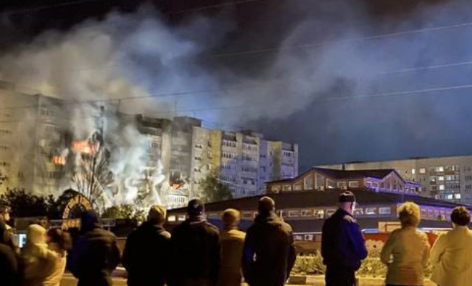

Earlier, the Russian Defense Ministry said the pilot of the plane had left the cockpit safely. The crash was caused by an engine failure. An engine caught fire almost immediately after takeoff, the pilot said.
此前，俄罗斯国防部表示，飞机飞行员已安全离开驾驶舱。坠机是由发动机故障引起的。飞行员说，起飞后几乎立即有一台发动机起火。

The Russian military added that the crashed plane was on a training flight. This means that the aircraft was not equipped with ammunition at the time of the incident.
俄罗斯军方补充说，坠毁的飞机正在进行训练飞行。这意味着飞机在事件发生时没有配备弹药。

At least 17 apartments were damaged, according to the governor of the Krasnodar region, where Yesk is located. The fire has been brought under control. Evacuation of residents of nearby apartment buildings has also been halted.
据叶斯克所在的克拉斯诺达尔地区州长称，飞机失事引发了一场大火，至少有 17 间公寓受损。火势已得到控制。附近公寓楼的居民疏散也已停止。

In a separate report, however, the Russian Ministry of Defense confirmed that the crashed plane was a Su-34, RT said. The plane crashed shortly after taking off from a local airport for a training flight.
然而，RT表示，在另一份报告中，俄罗斯国防部证实坠毁的飞机是Su-34。这架飞机在从当地机场起飞进行训练飞行后不久坠毁。

Video obtained by RT of the Russian plane crashing into an apartment building shows the plane flying low through the sky, with at least one explosion before it crashed.
RT获得的俄罗斯飞机坠入一栋公寓楼的视频显示，这架飞机在低空飞过天空，在坠毁前至少发生了一次爆炸。

CCTV footage shared by the Smotri Media Telegram channel also recorded the plane crash from a distance. In the video, the plane appears to be flying at a low speed and descending before crashing.
Smotri Media Telegram 频道分享的闭路电视录像也从远处记录了飞机失事。在视频中，这架飞机似乎在低速飞行，并在坠毁前下降。

In the video of the Russian plane crash released by the Marsh news agency, the apartment building was engulfed in flames and thick black smoke rose into the sky.
在马什通讯社发布的俄罗斯飞机失事现场的视频中，公寓楼被火焰吞没，浓浓的黑烟冲天而起。

Yeysk is a port city in southern Russia, separated from the Ukrainian city of Mariupol by the Sea of ​​Azov.
叶伊斯克是俄罗斯南部的港口城市，与乌克兰城市马里乌波尔隔着亚速海。

