Germany publishes the results of the investigation into the Nord Stream explosion
德国公布北溪爆炸调查结果

On October 17, Germany announced the results of its investigation into the Nord Stream pipeline explosion, similar to the preliminary results of Sweden.
10月17日，德国公布了北溪管道爆炸调查结果，与瑞典初步调查结果相似。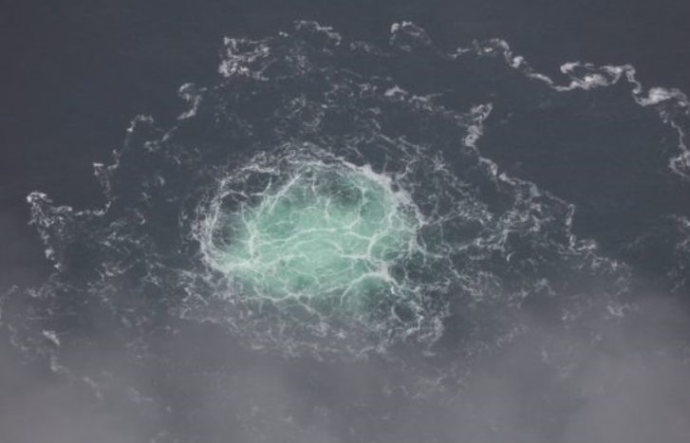

Leak from the Nord Stream 2 gas pipeline off the coast of southern Sweden in September
9 月，瑞典南部海岸的 北溪爆 2 天然气管道泄漏

Explosion suspected of sabotage
爆炸涉嫌蓄意破坏

The Wall Street Journal (WSJ) reported, German investigators determined that a series of explosions along the important gas pipelines Nord Stream 1 and Nord Stream 2 (Northern Stream 1, 2) running from Russia to Europe is likely due to sabotage. This result is similar to the preliminary findings of the Swedish officials.
《华尔街日报》（WSJ）报道，德国调查人员确定，从俄罗斯到欧洲的重要天然气管道 Nord Stream 1 和 Nord Stream 2（Northern Stream 1、2）沿线的一系列爆炸很可能是由于人为破坏造成的。这一结果与瑞典官员的初步调查结果相似。
German investigators have not been able to establish with certainty a link between the suspect and any agents. , but some German officials say they are working with the assumption that Russia was behind the explosions. The explosions created leaks affecting three of the four branches of Nord Stream 1 and Nord Stream 2 under the Baltic Sea.
德国调查人员无法确定嫌疑人与任何特工之间的联系。 ，但一些德国官员表示，他们正在假设俄罗斯是爆炸的幕后黑手。爆炸造成波罗的海下北溪 1 和北溪 2 四个分支中的三个泄漏。

Moscow denied responsibility and said the explosions were an attack.
莫斯科否认对此负责，称爆炸是一次袭击。

A preliminary Swedish investigation earlier this month concluded the explosions that took place in late September were likely sabotage, but did not name the perpetrators.
本月早些时候，瑞典的一项初步调查得出结论，9 月下旬发生的爆炸很可能是蓄意破坏，但没有说出肇事者的名字。
Play audio
播放音频

NATO said shortly after the attacks that the leaks were the result of sabotage but also did not provide any evidence or name the perpetrators.
北约在袭击发​​生后不久表示，泄漏是蓄意破坏的结果，但也没有提供任何证据或指名肇事者。

According to some German officials, it is unlikely that a military submarine would commit sabotage, as the water in the area is relatively shallow and the NATO navy regularly monitors it. submarine here.
根据一些德国官员的说法，军用潜艇不太可能进行破坏活动，因为该地区的水相对较浅，北约海军定期对其进行监测。

Play audio
播放音频

Another theory about the attack is that explosive devices were dropped from a ship and then detonated remotely, according to German officials.
关于这次袭击的另一种说法是，根据德国官员的说法，爆炸装置是从船上投下然后远程引爆的。
Nord Stream 1 is a pipeline. Russia's state-controlled energy group Gazprom's main gas exports to Western Europe until the company begins reducing flows this summer. Gazprom cut all supplies in August, citing technical problems and Western sanctions.
Nord Stream 1 是一条管道。俄罗斯国有控股能源集团俄罗斯天然气工业股份公司的主要天然气出口到西欧，直到该公司今年

Officials in several Western capitals say that Moscow's suspension of gas supplies is a political move in response to sanctions imposed by Russia's military campaign in Ukraine. Nord Stream 2, the newer pipeline built alongside Nord Stream 1, was completed last year but was never put into service. However, both pipes were filled with gas at the time of the incident. That gas leaked out for days, creating large bubbling puddles of water that made it impossible for ships to approach.
几个西方国家首都的官员表示，莫斯科暂停天然气供应是对俄罗斯在乌克兰的军事行动实施制裁的政治举措。 Nord Stream 2 是与 Nord Stream 1 一起建造的较新管道，于去年完工，但从未投入使用。然而，事故发生时，两条管道都充满了气体。这种气体泄漏了好几天，形成了大片冒泡的水坑，使船只无法靠近。

The only part of the pipeline that was not damaged by the explosions was one of the two branches of Nord Stream 2. Germany refused to certify Nord Stream 2 after Russia attacked Ukraine. President Vladimir Putin last week said it was possible to continue supplying gas to Germany via an undamaged pipeline, known as Nord Stream 2B.
唯一没有被爆炸损坏的管道部分是北溪 2 的两个分支之一。在俄罗斯袭击乌克兰后，德国拒绝对北溪 2 进行认证。总统弗拉基米尔·普京上周表示，有可能继续通过一条完好无损的管道向德国供应天然气，该管道被称为北溪 2B。

Germany has seen more frequent protests against Russia sanctions amid soaring electricity and heating bills.
在电费和取暖费飙升的情况下，德国出现了更频繁的抗议俄罗斯制裁的抗议活动。
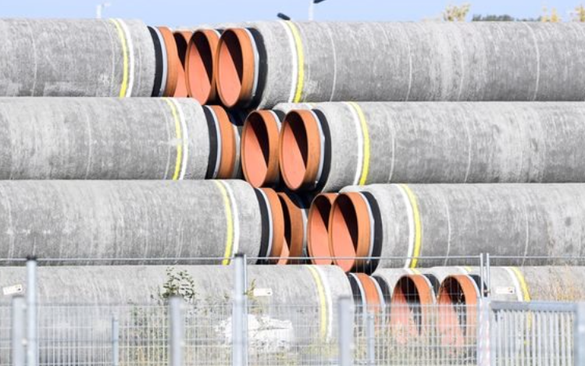

Separate investigations
分别排查

The Nord Stream 1 and Nord Stream 2 pipelines pass through the waters of Germany, Sweden and Denmark. All three countries have been investigating the incident. Swedish and Danish authorities have yet to release many details about their separate investigations. Germany's federal prosecutor has opened a criminal investigation into the attacks, suspected of sabotage.
北溪1号和北溪2号管道穿越德国、瑞典和丹麦水域。这三个国家都在调查这起事件。瑞典和丹麦当局尚未公布有关他们单独调查的许多细节。德国联邦检察官已对涉嫌蓄意破坏的袭击展开刑事调查。

In Sweden, the investigation is being led by the country's counterintelligence agency. In Denmark and Germany, the police and navy are involved in the investigations. For administrative reasons governing interagency intelligence sharing, Sweden will not conduct a joint investigation with the two neighbours, but officials said the three countries are working closely together,
在瑞典，调查由该国的反情报机构领导。在丹麦和德国，警方和海军都参与了调查。出于管理机构间情报共享的行政原因，瑞典不会与这两个邻国进行联合调查，但官员表示，这三个国家正在密切合作，

The explosion occurred at a depth of about 70 meters. Due to the depth and weather conditions, including underwater currents, German investigators were unable to use divers. Instead, they use underwater drones from the navy and surface ships, including minesweepers. Images from the blast sites show explosives with a yield of about 500 kg of TNT.
爆炸发生在深度约70米处。由于深度和天气条件，包括水下洋流，德国调查人员无法使用潜水员。相反，他们使用海军和水面舰艇的水下无人机，包括扫雷艇。爆炸现场的图像显示炸药的产量约为 500 公斤 TNT。
The investigation requires examination of undersea video, sonar evidence, as well as satellite imagery.
调查需要检查海底视频、声纳证据以及卫星图像。

