U.S. oil major leaves Russia empty-handed
美国石油巨头空手离开俄罗斯

Oil and gas giant Exxon Mobil has pulled out of Russia entirely after seven months of discussions over an orderly transfer of a 30 percent stake in the mega-project Sakhalin-1.
石油和天然气巨头埃克森美孚在就有序转让 Sakhalin-1 大型项目 30% 股权进行了七个月的讨论后，已完全退出俄罗斯。
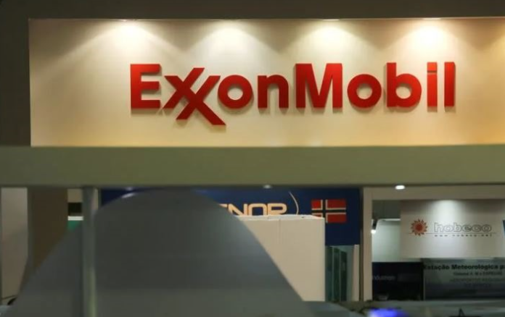

埃克森美孚没有透露其价值超过 40 亿美元的资产是否收到了任何补偿。埃克森美孚的一位发言人拒绝评论该公司是否已采取措施将此案提交国际仲裁。这是八月份提到的选项。
Exxon did not disclose whether it received any compensation for assets worth more than $4 billion. A spokesman for Exxon declined to comment on whether the company had taken steps to bring the case to international arbitration. This is the option mentioned in August.

"We have made every effort to engage with the Russian government and other stakeholders," an Exxon Mobil spokesman said.
“我们已尽一切努力与俄罗斯政府和其他利益相关者接触，”埃克森美孚发言人说。

The company said it had "safely left Russia" after the government "unilaterally terminated" its interest in the Sakhalin-1 oil and gas project, the country's largest project. Since March 1, ExxonMobil has been trying to ditch Sakhalin-1 operations, leaving room for the possibility of selling more than $4 billion in assets at the Sakhalin-1 project.
该公司表示，在政府“单方面终止”其在该国最大项目 Sakhalin-1 石油和天然气项目中的权益后，它已“安全离开俄罗斯”。自 3 月 1 日以来，埃克森美孚一直试图放弃 Sakhalin-1 的运营，从而为出售Sakhalin-1 项目超过 40 亿美元资产的可能性留有余地。

The airline said it would "closely coordinate" the transfer of operations with its partners - Russia's Rosneft, India's ONGC Videsh and Japan's SODECO - to ensure process safety.

Before ExxonMobil, BP, TotalEnergies, Equinor and Shell all transferred assets to Russian partners or abandoned operations.
在埃克森美孚之前，BP、TotalEnergies、Equinor 和壳牌都将资产转让给俄罗斯合作伙伴或放弃运营。

On October 7, Russian President Vladimir Putin signed a decree to take control of ExxonMobil's stake in an oil production joint venture and transfer it to a government-controlled company. Exxon has reduced operations in Russia since 2014 after Moscow annexed the Crimea peninsula from Ukraine.
10月7日，俄罗斯总统弗拉基米尔·普京签署法令，控制埃克森美孚在一家石油生产合资企业的股份，并将其转让给一家政府控制的公司。自 2014 年以来，在莫斯科从乌克兰吞并克里米亚半岛后，埃克森美孚减少了在俄罗斯的业务。

Earlier this year, U.S. oil and gas companies stopped allowing foreign workers to enter Russia and closed their chemical and lubricants operations in Russia.
今年早些时候，美国石油和天然气公司停止允许外国工人进入俄罗斯，并关闭了在俄罗斯的化学和润滑油业务。
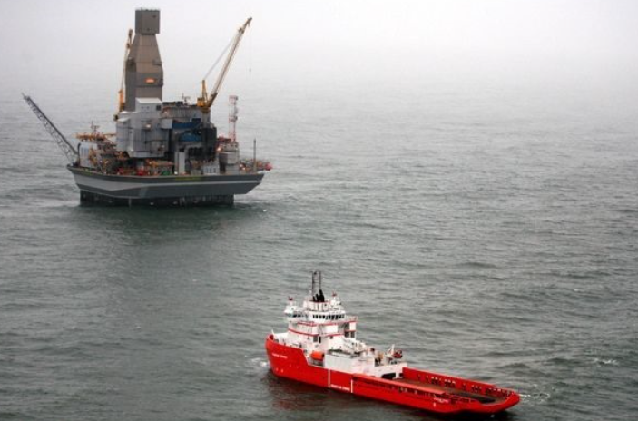

By July, production at the Sakhalin-1 project had fallen to 10,000 bpd from 220,000 bpd before the Ukrainian war. That volume is just enough to supply gas to keep the lights on in Khabarovsk and Vladivostok, Russia.
到 7 月，Sakhalin-1 项目的产量已从乌克兰战争前的 220,000 桶/日降至 10,000 桶/日。这个体积刚好够供应天然气来维持俄罗斯哈巴罗夫斯克和符拉迪沃斯托克的灯火。

ExxonMobil said about 700 employees maintaining operations in Russia will be transferred to a new Russian company to take over the project.
埃克森美孚表示，在俄罗斯维持运营的约 700 名员工将被转移到新的俄罗斯公司接管该项目。
ExxonMobil has committed to taking the time to provide the new operator with a safe handover to avoid oil spills, environmental incidents or lights out in cities provided by the Sakhalin-1 project.
埃克森美孚承诺花时间向新运营商提供安全移交，以避免在 Sakhalin-1 项目提供的城市发生漏油、环境事故或熄灯。

Russia clause prevents Exxon from transferring or negotiating sales to Indian or Japanese partners.
俄罗斯条款阻止埃克森美孚将业务转移或谈判销售给印度或日本合作伙伴。

India's oil and gas group plans to buy a stake in the new entity that will manage Russia's Sakhalin-1 project to retain a 20 percent stake in the project, three sources told Reuters.
三位消息人士告诉路透社，印度石油和天然气集团计划购买新实体的股份，该实体将管理俄

Sakhalin-1 project in Ross to retain a 20% stake in the project.
Japanese Industry Minister Yasunori Nishimura said earlier this week that Japan will decide how to handle the Sakhalin-1 oil and gas project in Russia's Far East in consultation with its partners as it reviews the details of the Moscow decree.
罗斯的 Sakhalin-1 项目，以保留该项目 20% 的股份。
日本工业大臣西村康稔本周之前表示，日本将在审查莫斯科法令的细节时与其合作伙伴协商，决定如何处理俄罗斯远东地区的 Sakhalin-1 石油和天然气项目。

According to President Vladimir Putin's decree of October 7, after the establishment of the new Russian company, the foreign partners of the Sakhalin-1 project will have a month to ask the Russian government to split the shares of the new company .
根据普京总统10月7日的法令，在俄罗斯新公司成立后，库页岛一号项目的外国合作伙伴将有一个月的时间要求俄罗斯政府拆分新公司的股份。

